**MEDIA STREAMING USING IBM CLOUD FOUNDRY**

**DOMAIN:CLOUD APPLICATION DEVELOPMENT**

**TEAM MEMBERS:**

**N.SUCHARITHA**

**N.SUBHASHINI**

**KA.VAISHNAVI**

**R.PRIYA**

**INTRODUCTION**

In conclusion, using IBM Cloud Foundry for media streaming offers a reliable and scalable solution for delivering high-quality content to a wide audience. This platform provides the necessary infrastructure and tools to host, manage, and optimize media streaming applications, ensuring a seamless and efficient experience for users. With IBM Cloud Foundry, you can leverage cloud-based resources and services to enhance the performance, security, and accessibility of your media streaming applications, ultimately contributing to a successful and engaging user experience.

**FEATURE ENGINEERING**

Feature engineering for media streaming in the context of IBM Cloud involves designing and creating data features to improve the performance and capabilities of your media streaming platform. Here are some steps and considerations for feature engineering in this scenario:

1. **Data Collection:**

Gather data related to your media streaming service, such as user interaction data, content metadata, and performance metrics. This data can come from various sources, including user logs, content databases, and streaming server logs.

1. **Data Preprocessing:**

Clean and preprocess the collected data. This may involve handling missing values, removing outliers, and normalizing or scaling data as needed.

1. **Feature Selection:**

Identify relevant features that can impact your media streaming service. These could include user demographics, content genres, playback quality, and more. Consider using domain knowledge and data analysis techniques to select the most valuable features.

1. **Feature Engineering:**

Create new features or transform existing ones to extract valuable information. For media streaming, this could involve creating features like user engagement scores, content popularity scores, or quality of experience (QoE) metrics based on buffering and playback data.

1. **Incorporate Real-time Data:**

For live media streaming, consider incorporating real-time data from streaming servers and user interactions. This can enable dynamic feature engineering and personalization in real-time.

1. **Machine Learning Models:**

Utilize machine learning models to leverage these engineered features. You can use models to predict user behavior, recommend content, or optimize streaming quality. IBM Cloud offers various services for building and deploying machine learning models, such as IBM Watson Machine Learning.

1. **A/B Testing:**

Use A/B testing to evaluate the impact of your feature engineering efforts. Compare the performance of your media streaming service with and without the engineered features to measure their effectiveness.

1. **Scalability and Cost Considerations:**

Ensure that your feature engineering and machine learning solutions are scalable and cost-effective in the cloud environment. IBM Cloud provides resources for autoscaling and cost optimization.

1. **Monitoring and Maintenance:**

Continuously monitor the performance of your feature-engineered models and features. Update them as needed to adapt to changing user behaviors and streaming patterns.

1. **Data Security and Compliance**:

Ensure that you handle user data and content metadata with privacy and compliance in mind. IBM Cloud provides tools and services to help with data security and compliance requirements.

**MODEL ENGINEERING**

Training machine learning models for media streaming using IBM Cloud involves leveraging cloud-based resources and services to build, train, and deploy models that improve the user experience and optimize content delivery. Here are the steps for model training in this context:

1. **Data Collection:**

Gather relevant data from your media streaming platform, such as user behavior data, content metadata, streaming server logs, and any other data sources that can inform your models.

1. **Data Preparation:**

Clean, preprocess, and format the collected data to make it suitable for model training. This may involve handling missing values, encoding categorical features, and normalizing data.

1. **Data Storage:**

Store your data in a scalable and accessible storage solution provided by IBM Cloud, such as IBM Cloud Object Storage or IBM Cloud Databases, for easy access by training processes.

1. **Choose Machine Learning Algorithms:**

Select the appropriate machine learning algorithms for your specific use case. For media streaming, this might involve recommendation systems, user behavior prediction, or content quality optimization. Common algorithms include collaborative filtering, deep learning, and reinforcement learning.

1. **Model Training Infrastructure:**

Utilize IBM Cloud's computing resources, such as IBM Watson Machine Learning, IBM Cloud Functions, or IBM Cloud Kubernetes Service, to train your machine learning models at scale. These services offer the computational power needed for training complex models.

1. **Hyperparameter Tuning:**

Fine-tune your models by optimizing hyperparameters to improve their performance. You can use tools like IBM Watson AutoAI to automate this process and find the best hyperparameter settings.

1. **Cross-Validation and Evaluation:**

Assess the performance of your models using cross-validation and evaluation metrics relevant to your use case. Common metrics include Mean Absolute Error (MAE), Root Mean Squared Error (RMSE), and precision-recall for recommendation systems.

1. **Deploy Models:**

Once your models are trained and validated, deploy them on IBM Cloud using services like IBM Watson Machine Learning or IBM Cloud Kubernetes Service. This allows you to serve predictions or recommendations in real-time.

1. **Monitor and Maintain**:

Continuously monitor model performance in production. Set up alerts to detect issues, retrain models as needed to adapt to changing user behavior, and maintain model versions.

1. **A/B Testing:**

Implement A/B testing to compare the performance of models with different algorithms or feature sets. This helps you make data-driven decisions about which models work best for your media streaming platform.

1. **Scalability and Cost Considerations**:

Ensure that your model training and deployment processes are cost-effective and scalable. IBM Cloud provides resources for autoscaling and cost optimization.

1. **Data Security and Compliance:**

Keep data security and compliance in mind when handling user data and content information. IBM Cloud provides tools and services for data security and compliance management.

IBM Cloud offers a variety of resources, including machine learning tools and cloud infrastructure, to support model training for media streaming. Leveraging these services can help you create personalized and high-quality media streaming experiences for your users.

**FEATURE FOR MODEL TRAINING**

When training machine learning models for media streaming using IBM Cloud Foundry, you can utilize various features and capabilities provided by the platform to enhance the training process. Here are some key features and considerations:

1.**Data Ingestion**:

IBM Cloud Foundry allows you to ingest and process large volumes of data efficiently. You can use Cloud Foundry services like IBM Cloud Databases, IBM Cloud Object Storage, or third-party data storage solutions to store and manage your media streaming data.

2.**Scalability**:

One of the advantages of Cloud Foundry is its scalability. You can scale your model training infrastructure horizontally to handle larger datasets and more complex models. This can be achieved through load balancing and auto-scaling features.

**3.Containerization**:

Use containerization platforms like Docker and Kubernetes on IBM Cloud Foundry to package your model training code and dependencies. This ensures consistent and reproducible model training environments.

4.**Model Deployment:**

After training your models, deploy them on Cloud Foundry to make predictions or recommendations in real-time. This can be done using containerized services or serverless functions, depending on your specific use case.

5.**Logging and Monitoring:**

Cloud Foundry provides built-in monitoring and logging capabilities, which are crucial for tracking the progress and performance of your model training process. You can use tools like IBM Cloud Monitoring and IBM Log Analysis for detailed insights.

**6.Auto-Scaling:**

Leverage Cloud Foundry’s auto-scaling capabilities to dynamically adjust resources as needed during model training. This ensures optimal resource allocation and cost efficiency.

7.**Machine Learning Frameworks:**

Cloud Foundry supports various machine learning frameworks and libraries, allowing you to choose the tools that best fit your model training needs. Popular frameworks like TensorFlow, PyTorch, and scikit-learn can be installed and used.

**8.Integration with IBM Watson Services:** Integrate your model training pipeline with IBM Watson services, such as Watson Machine Learning. This allows you to take advantage of pre-built ML capabilities and manage your models more effectively.

**9.Data Pipelines**:

Implement data pipelines to preprocess and transform your media streaming data before model training. Cloud Foundry provides tools for building and managing data pipelines, ensuring data quality and consistency.

10.**A/B Testing**:

Deploy multiple versions of your trained models on Cloud Foundry to conduct A/B testing and compare the performance of different model configurations in a controlled environment.

11.**Version Control:**

Use version control systems to manage your model training code and track changes over time. This helps ensure reproducibility and collaboration among data scientists and engineers.

1. **Security and Compliance:**

Ensure that your model training process complies with security and privacy standards. IBM Cloud Foundry offers security features and practices to protect sensitive data.

By leveraging these features and capabilities of IBM Cloud Foundry, you can streamline and optimize the model training process for media streaming, making it more efficient and effective in delivering high-quality user experiences.

**DEVELOPING MEDIA STREAMING PLATFORM**

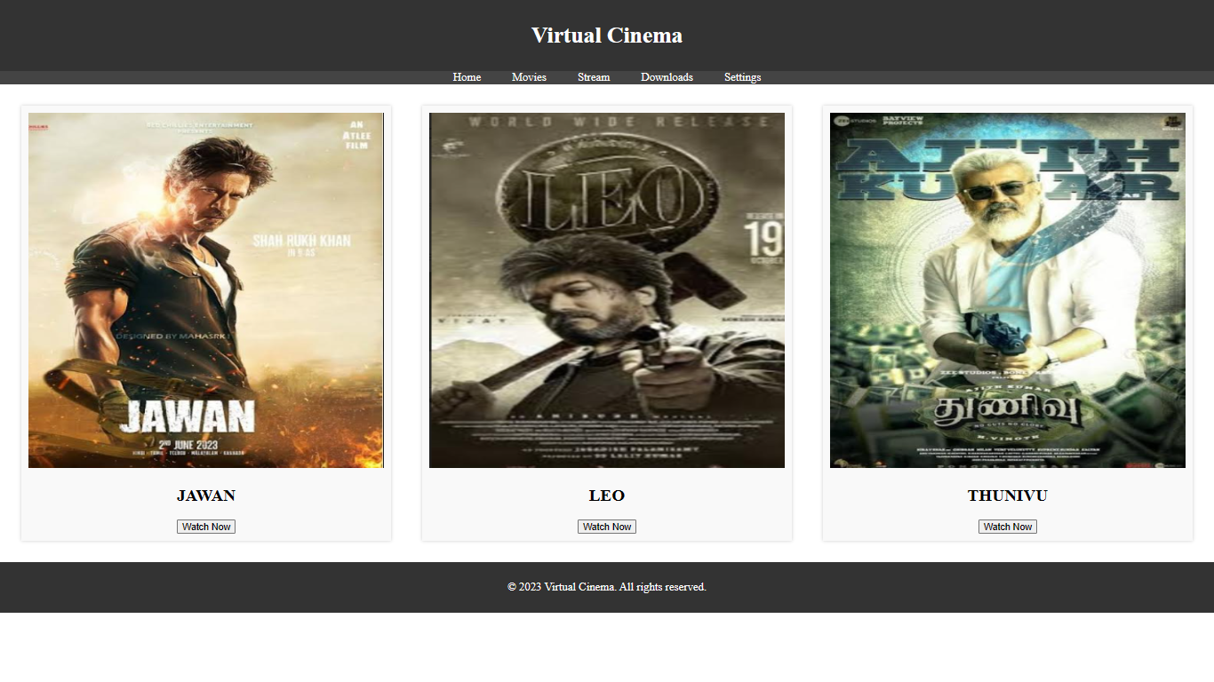

**CONCLUSIONS**

In conclusion, using IBM Cloud Foundry for media streaming offers a reliable and scalable solution for delivering high-quality content to a wide audience. This platform provides the necessary infrastructure and tools to host, manage, and optimize media streaming applications, ensuring a seamless and efficient experience for users. With IBM Cloud Foundry, you can leverage cloud-based resources and services to enhance the performance, security, and accessibility of your media streaming applications, ultimately contributing to a successful and engaging user experience.